Clinometer
# Source: AI Source: Provided by: [Data Path: Persons Table -> ID Column: 1, Name_En Column: Motasem Essam] -> From: [ChatGPT] on [7/17/2026]
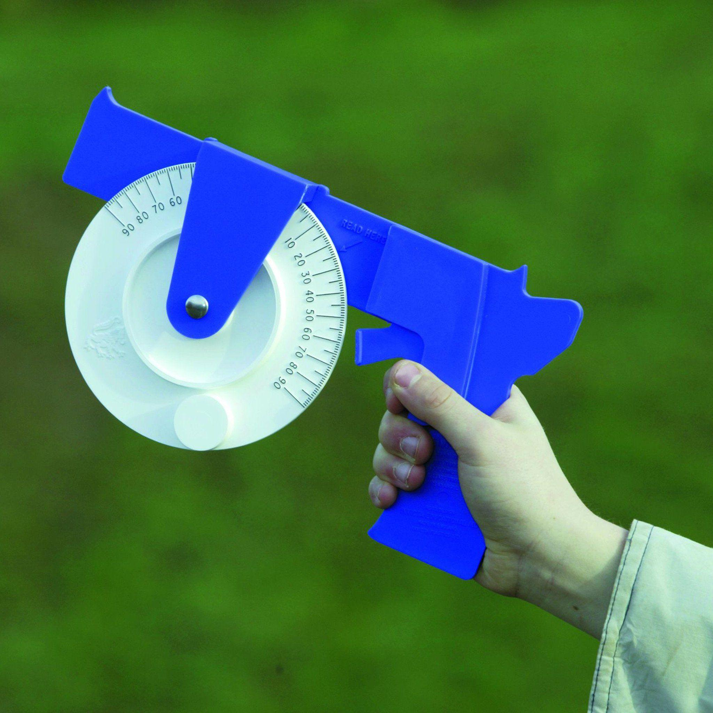
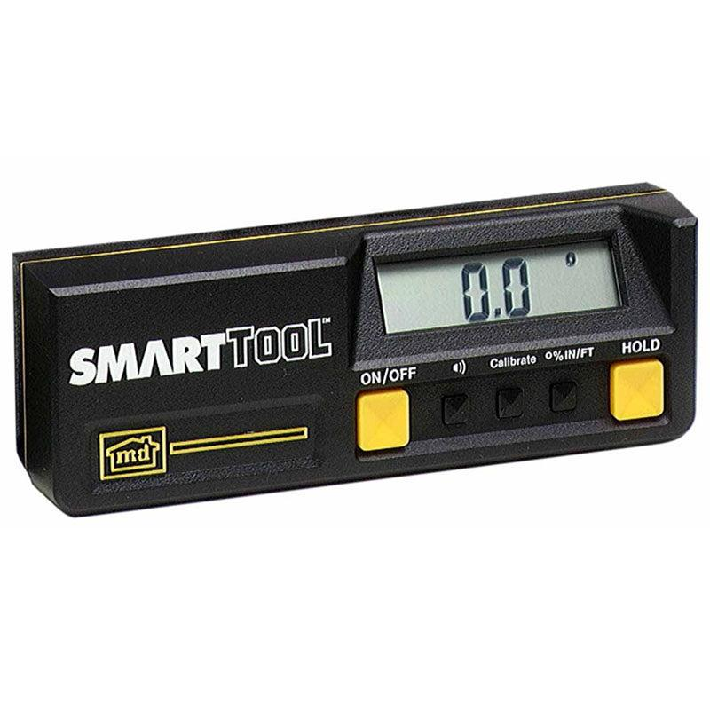
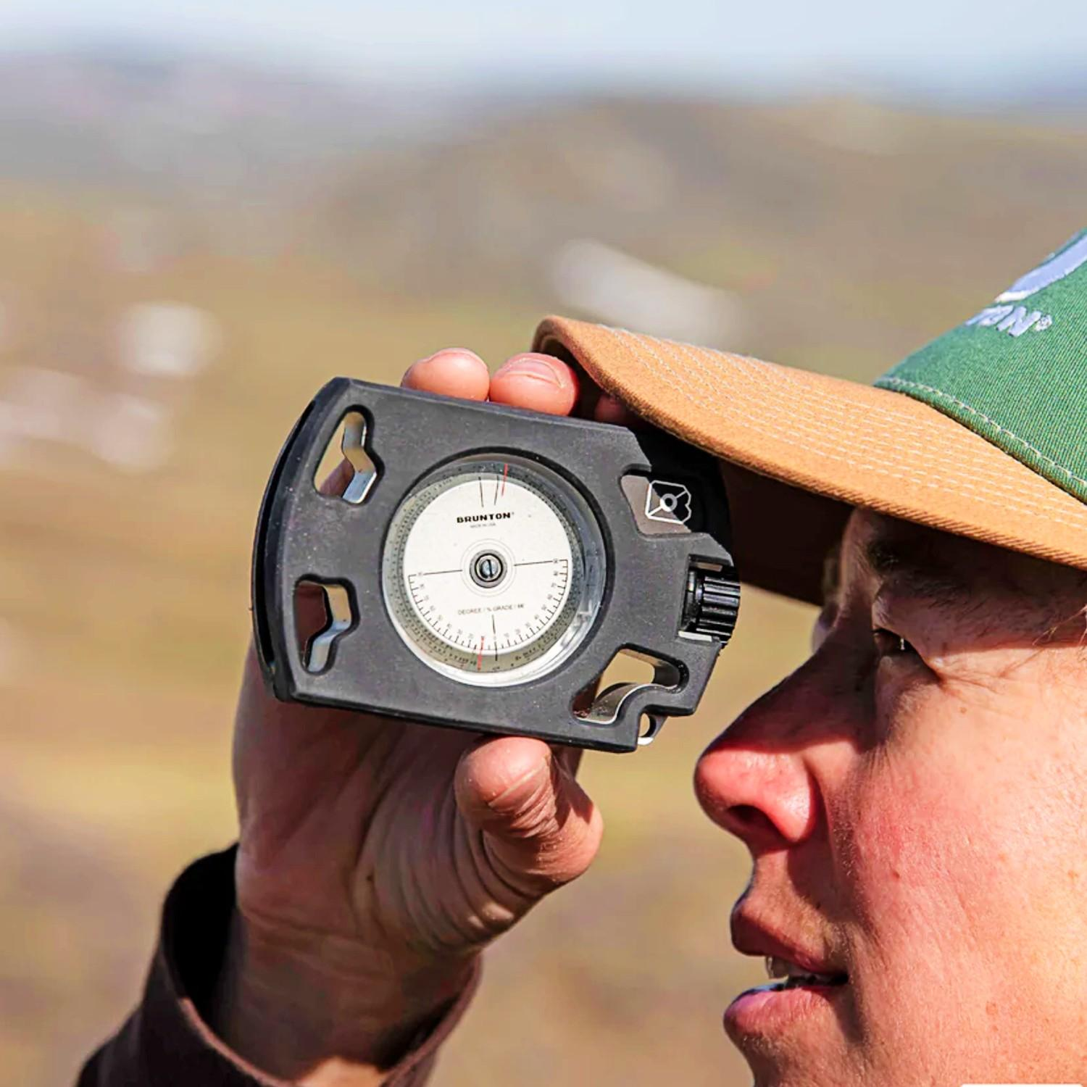
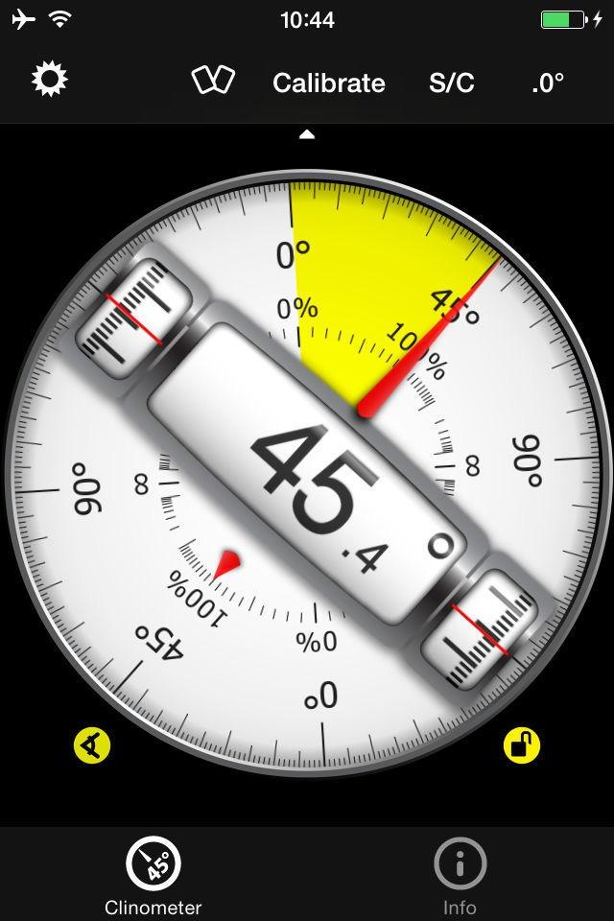
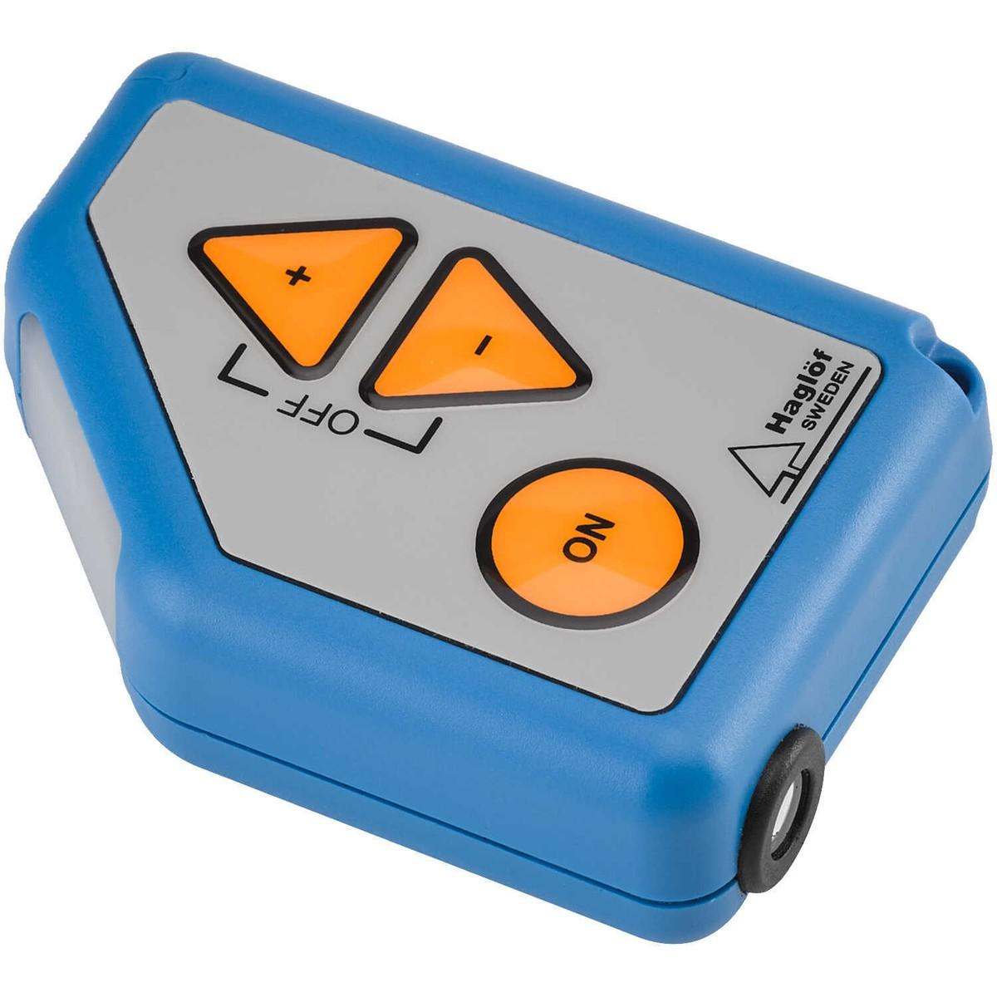
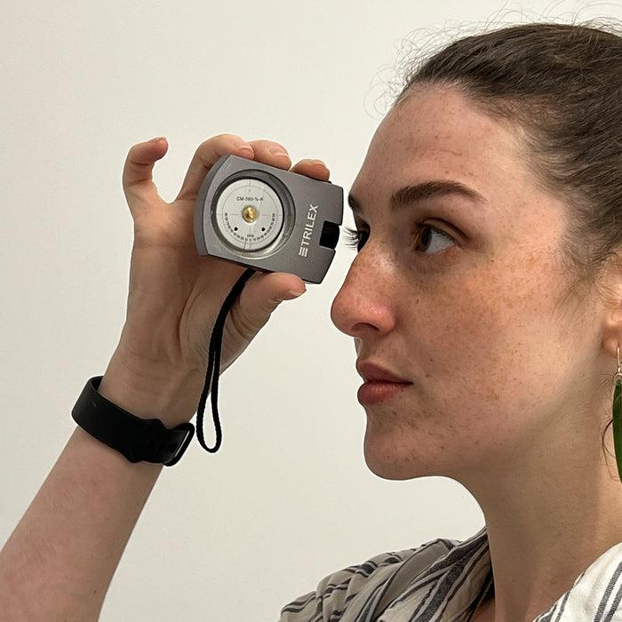
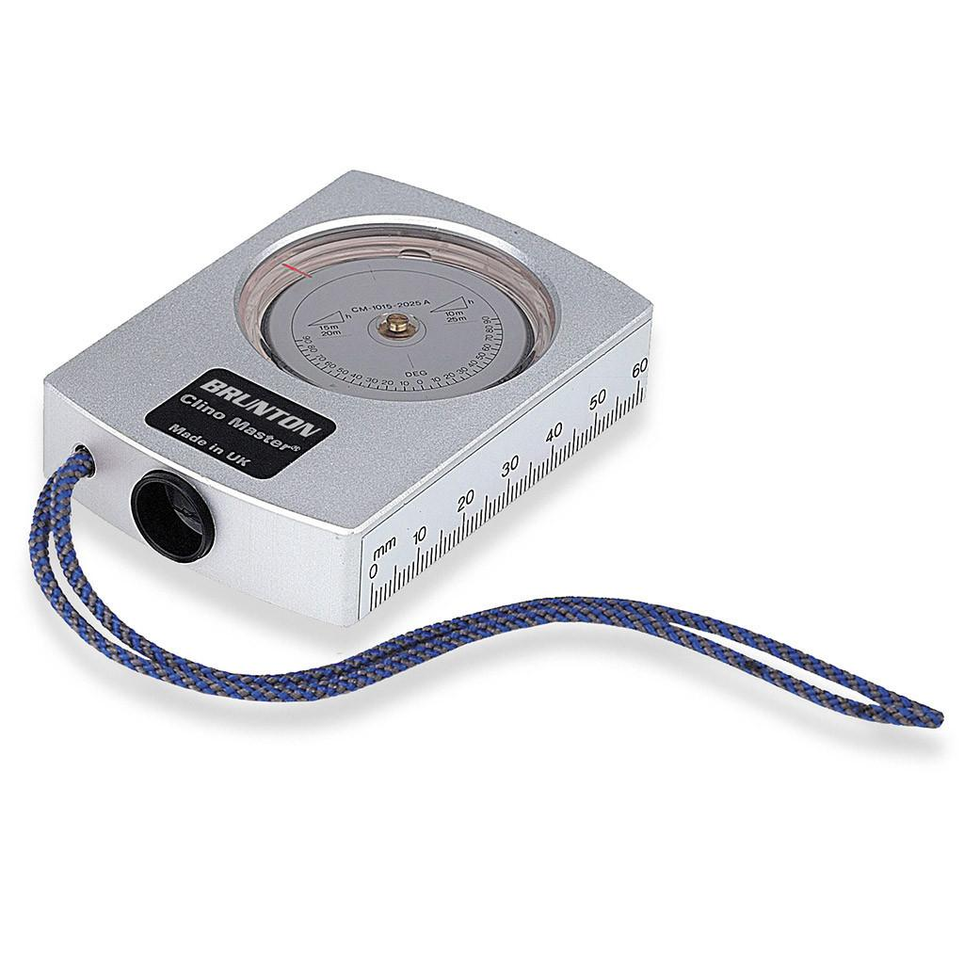
A Clinometer (also called an Inclinometer, Slope Meter, or Tilt Meter) is an angle-measuring instrument used to measure the angle of inclination, slope, tilt, or elevation of an object relative to the horizontal or vertical.
Clinometers are widely used in surveying, geology, forestry, civil engineering, construction, mining, aviation, navigation, and sports.

Definition
# Source: AI Source: Provided by: [Data Path: Persons Table -> ID Column: 1, Name_En Column: Motasem Essam] -> From: [ChatGPT] on [7/17/2026]
A Clinometer is an angle-measuring instrument used to determine the angle of slope, elevation, depression, or tilt of an object relative to a horizontal or vertical reference.

Purpose
# Source: AI Source: Provided by: [Data Path: Persons Table -> ID Column: 1, Name_En Column: Motasem Essam] -> From: [ChatGPT] on [7/17/2026]
A clinometer is used to:
- Measure slopes.
- Measure inclinations.
- Measure elevation angles.
- Measure depression angles.
- Determine roof pitch.
- Measure hill gradients.
- Estimate tree heights (with distance measurements).
- Check equipment alignment.

Principle of Operation
# Source: AI Source: Provided by: [Data Path: Persons Table -> ID Column: 1, Name_En Column: Motasem Essam] -> From: [ChatGPT] on [7/17/2026]
Traditional clinometers operate using gravity.
A weighted pointer, pendulum, or fluid level always aligns with the direction of gravity. The angle between this reference and the instrument body is read on a graduated scale.
Digital clinometers use:
- MEMS accelerometers
- Electronic tilt sensors
- Gyroscopes
to calculate the angle electronically.

Main Components
# Source: AI Source: Provided by: [Data Path: Persons Table -> ID Column: 1, Name_En Column: Motasem Essam] -> From: [ChatGPT] on [7/17/2026]
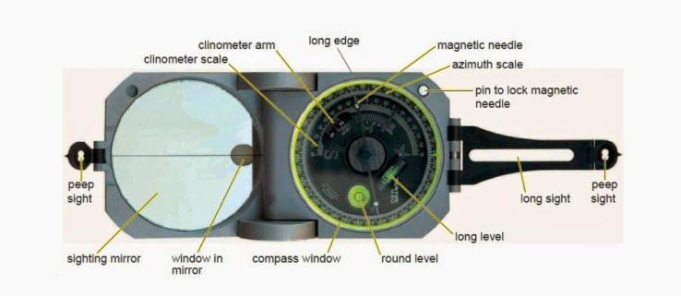
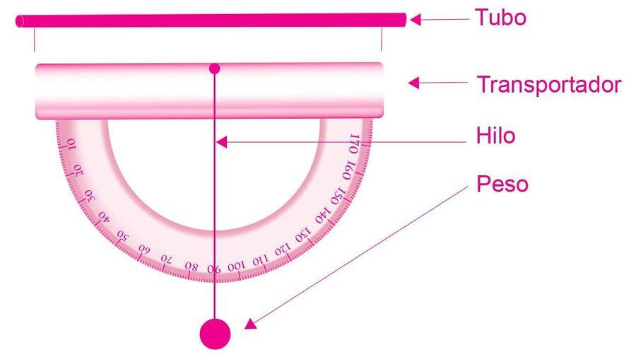
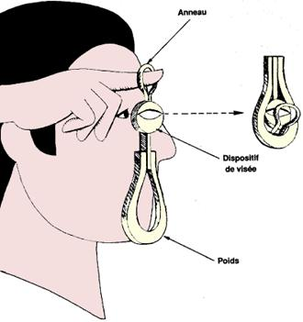
A typical clinometer consists of:
- Angle scale
- Pointer or pendulum
- Viewing window
- Sighting line or tube
- Spirit level (some models)
- Housing
- Digital display (electronic models)
- Control buttons (digital models)

Types of Clinometers

1. Mechanical Clinometer
# Source: AI Source: Provided by: [Data Path: Persons Table -> ID Column: 1, Name_En Column: Motasem Essam] -> From: [ChatGPT] on [7/17/2026]
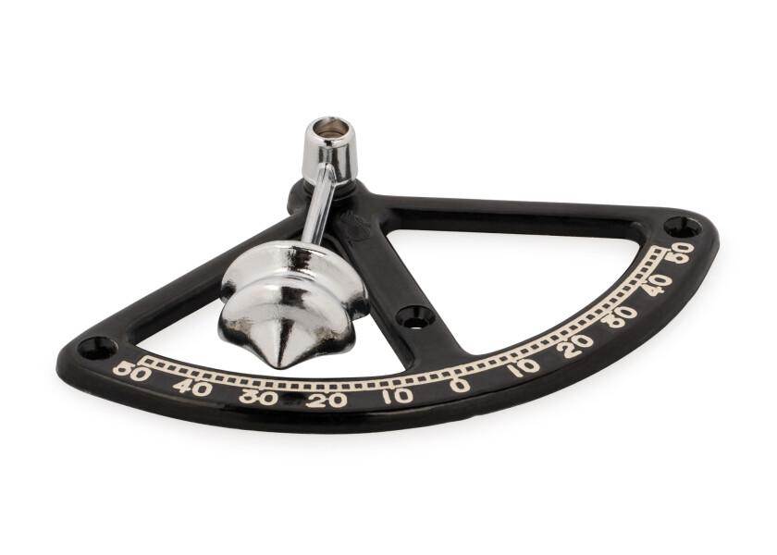
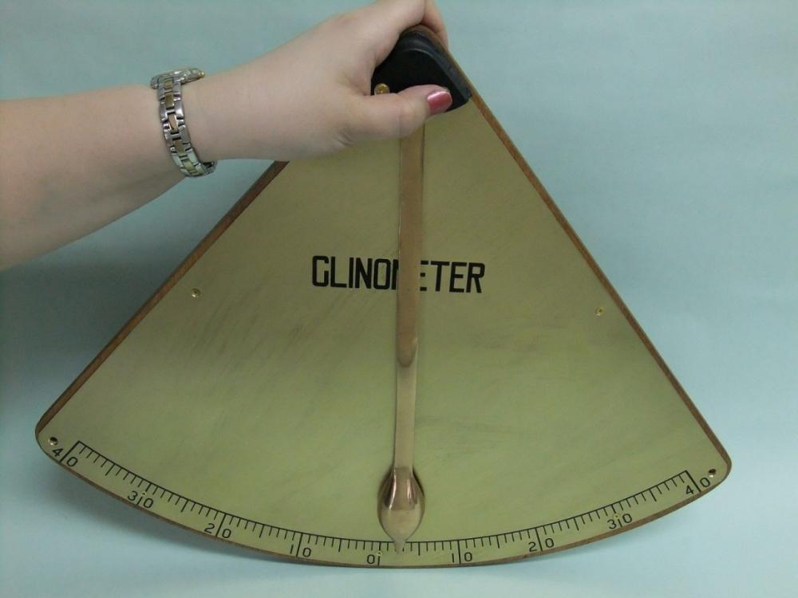
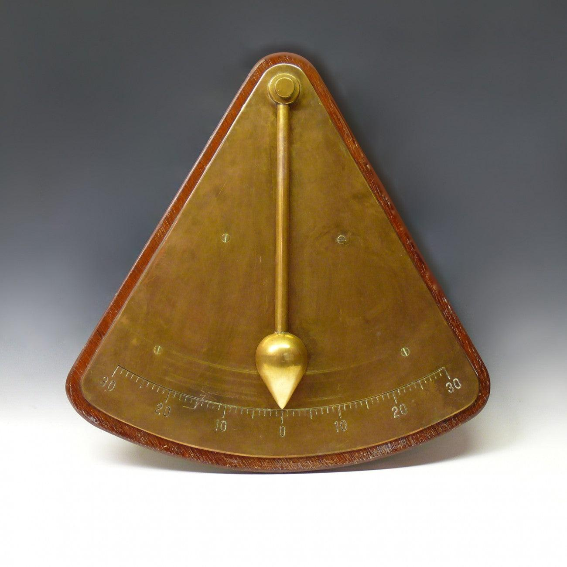
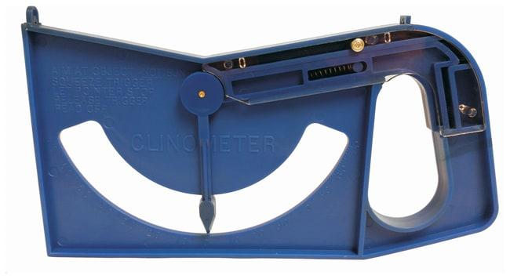
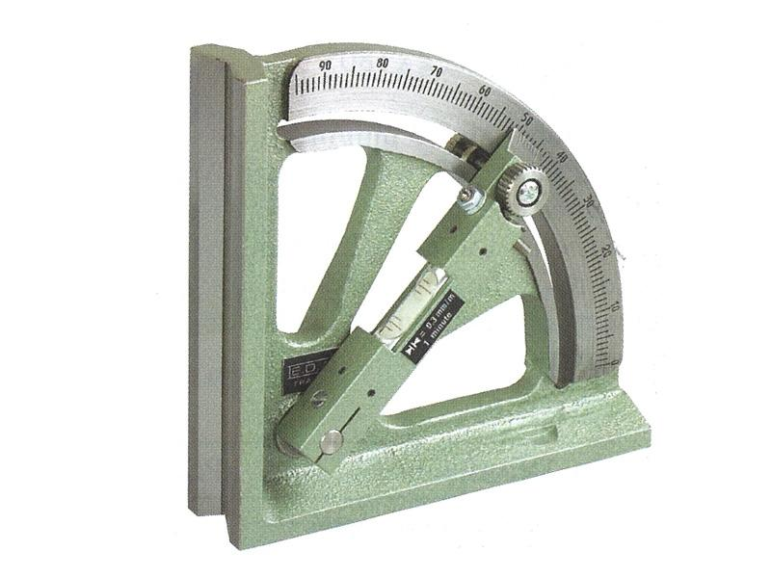
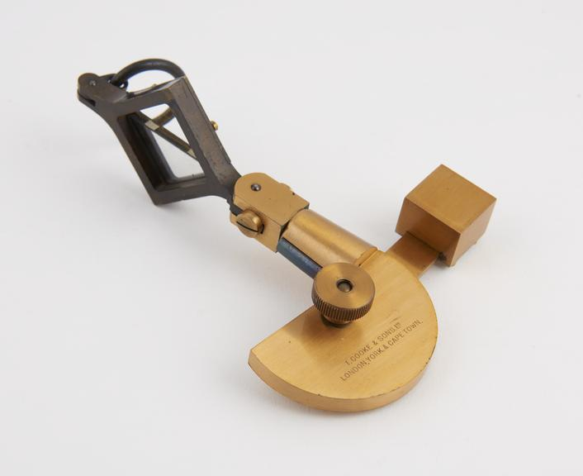
Description
Uses a pendulum or weighted pointer to indicate the angle.
Features
- No batteries
- Simple construction
- Easy to use
Applications
- Education
- Surveying
- Construction

2. Digital Clinometer
# Source: AI Source: Provided by: [Data Path: Persons Table -> ID Column: 1, Name_En Column: Motasem Essam] -> From: [ChatGPT] on [7/17/2026]


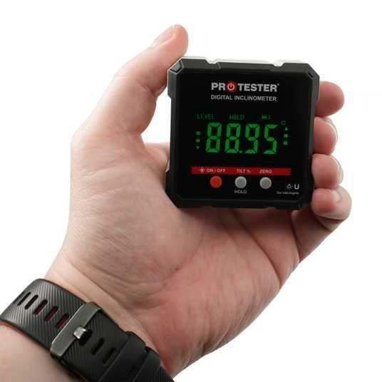
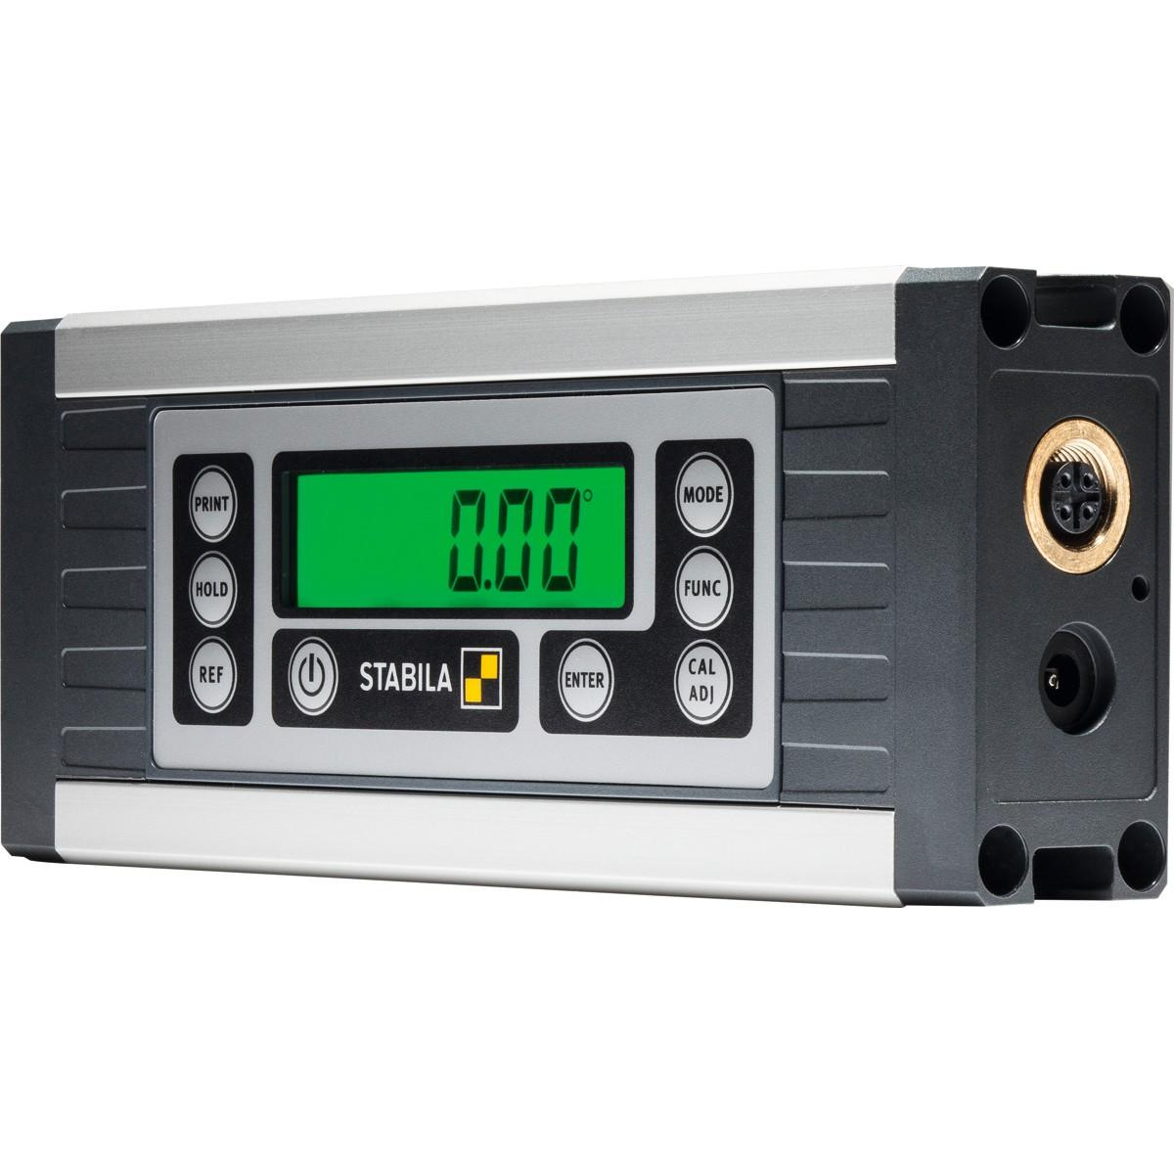
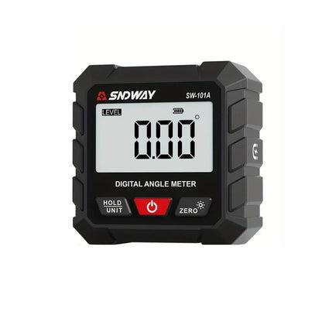
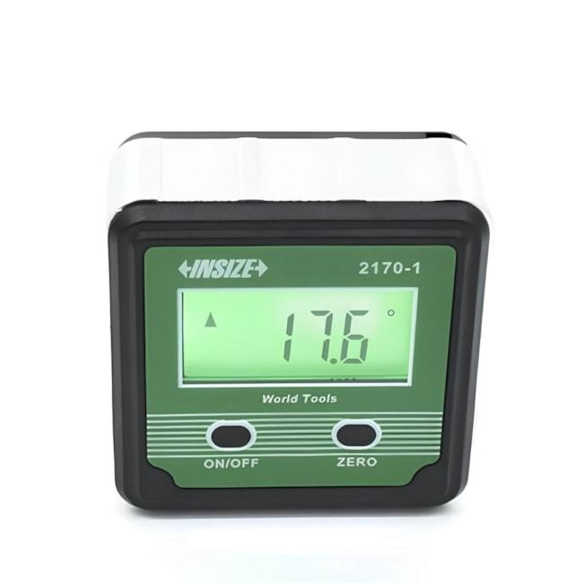
Description
Uses electronic tilt sensors and displays the angle digitally.
Features
- High accuracy
- LCD display
- Multiple units
- Zero calibration
Applications
- Construction
- Engineering
- Manufacturing

3. Geological Clinometer
# Source: AI Source: Provided by: [Data Path: Persons Table -> ID Column: 1, Name_En Column: Motasem Essam] -> From: [ChatGPT] on [7/17/2026]
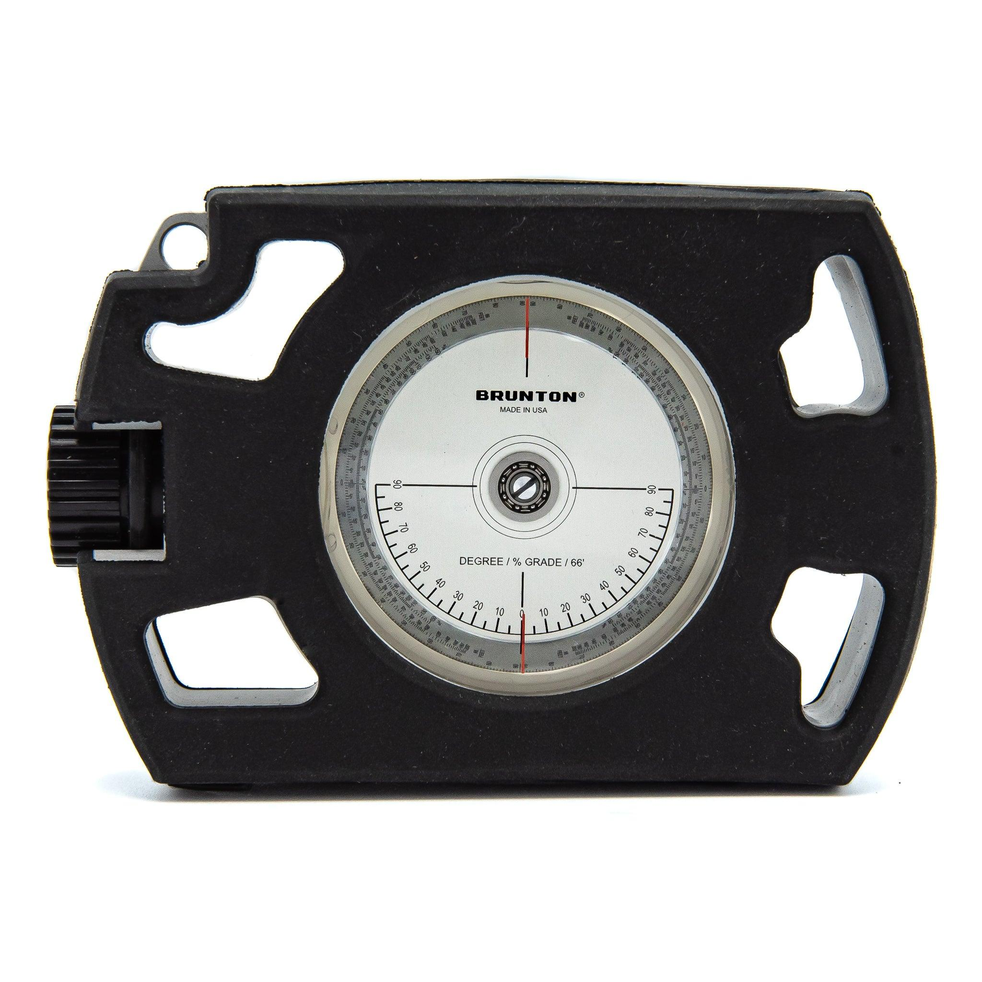

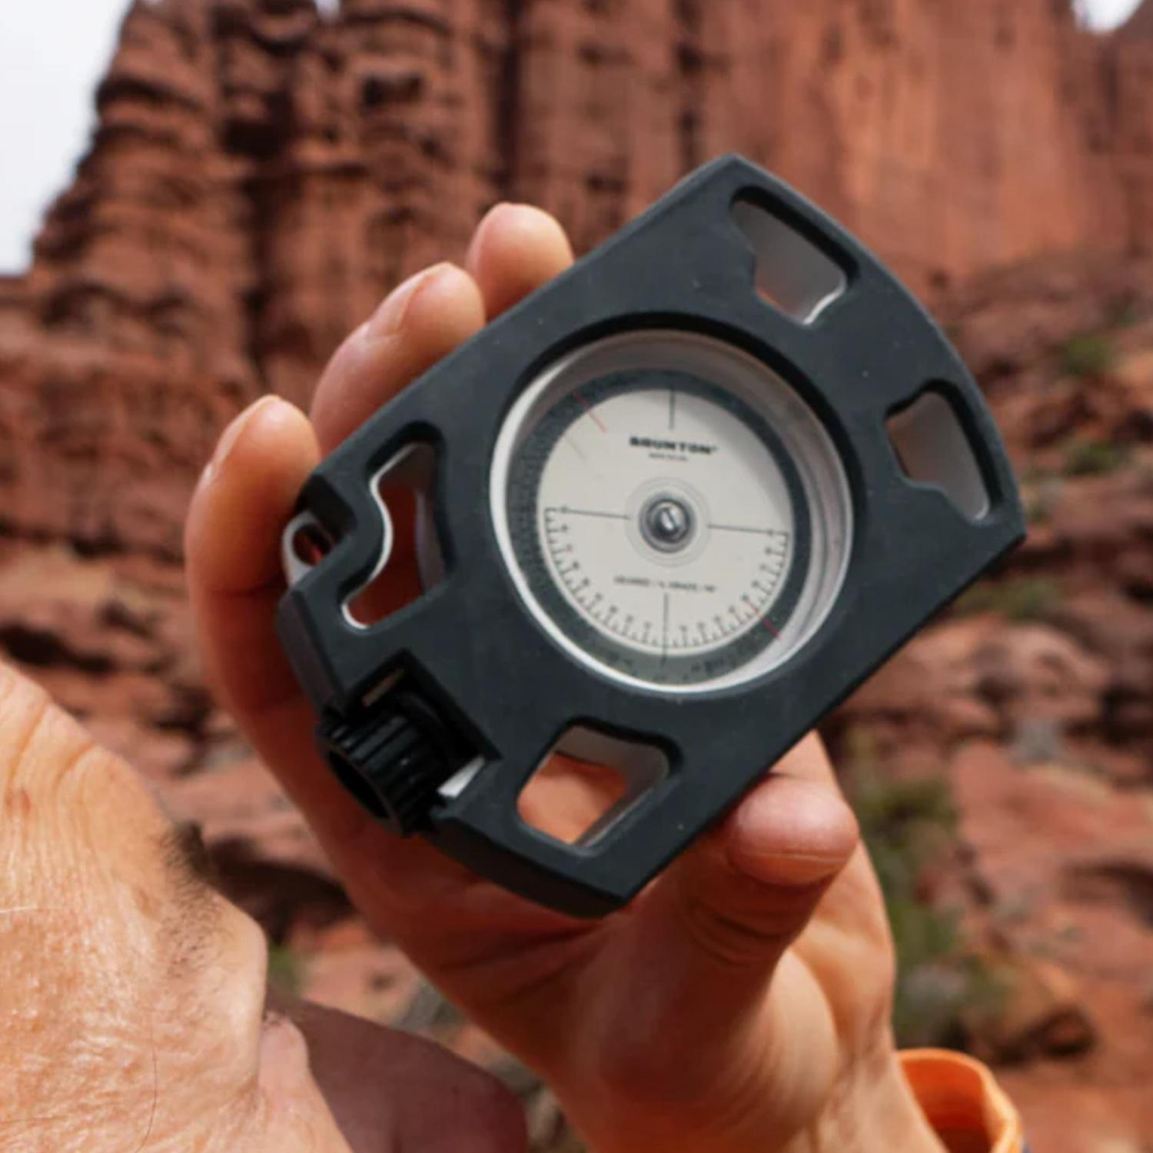
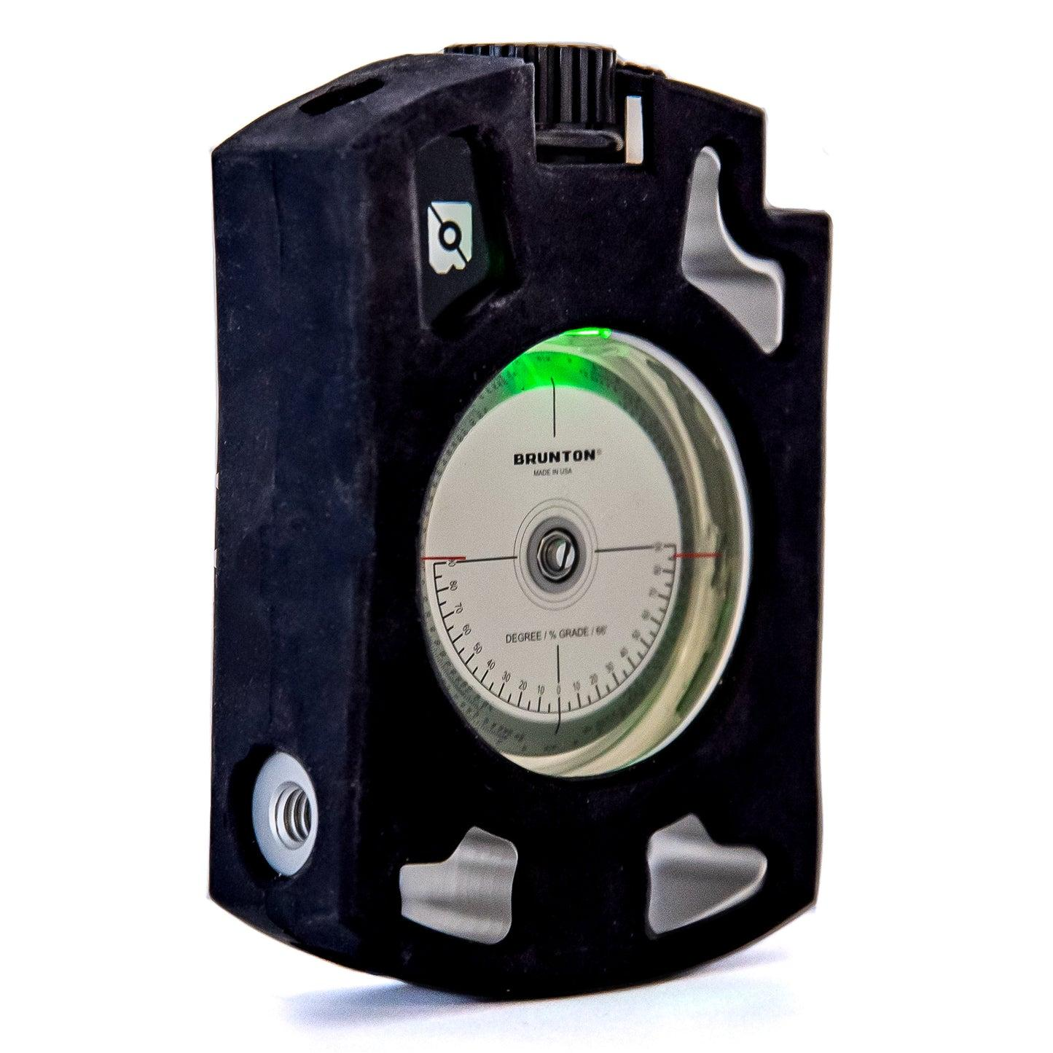
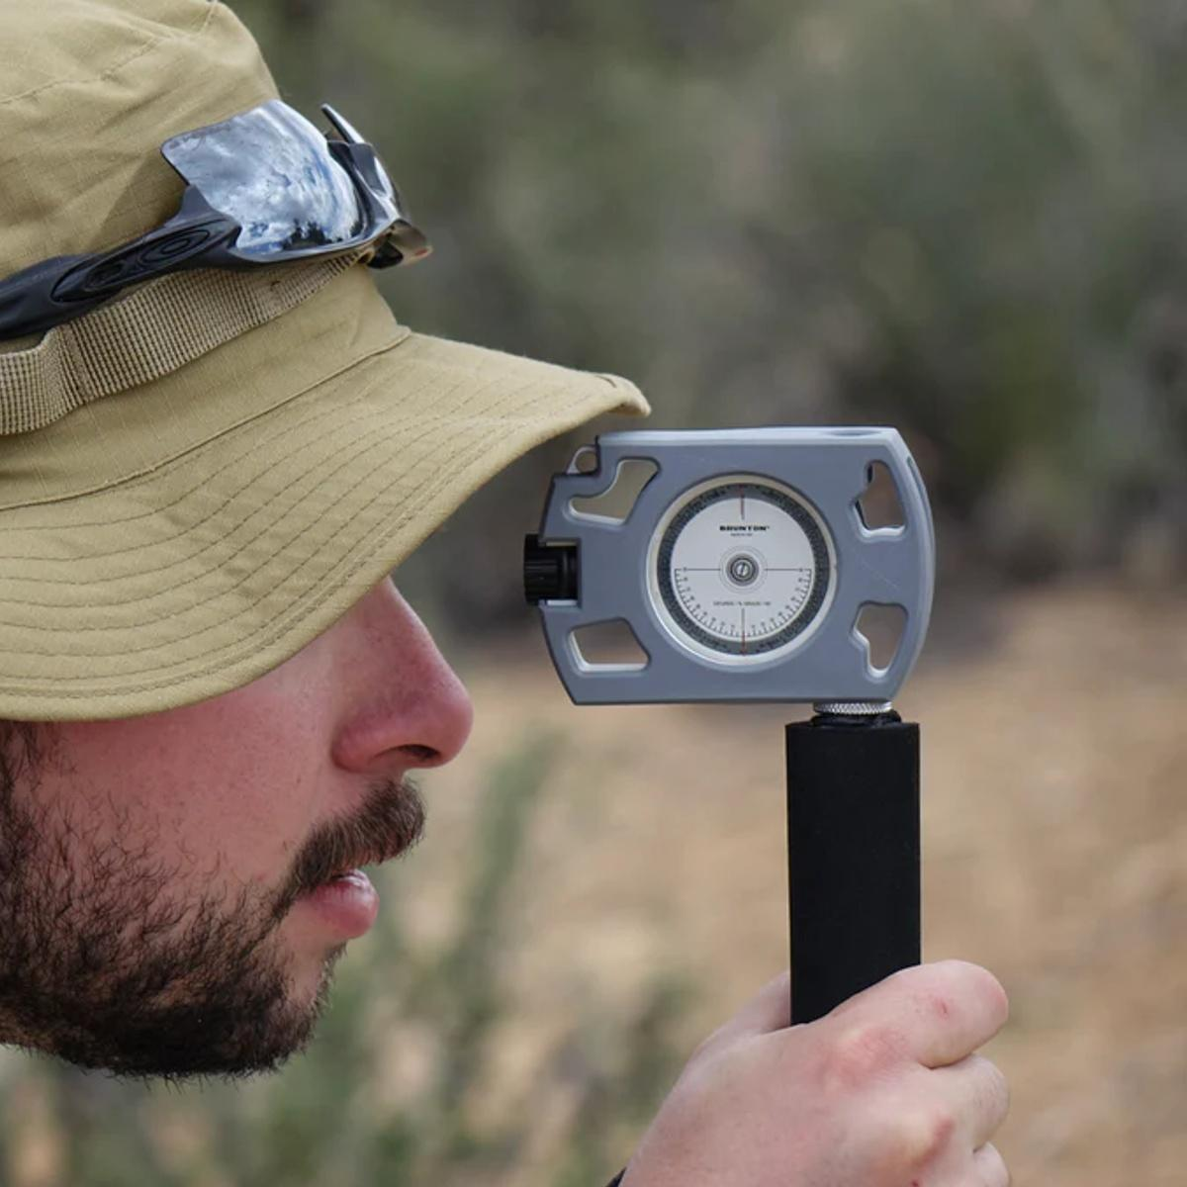
Description
Designed for measuring rock formations, fault angles, and geological structures.
Applications
- Geology
- Mining
- Field surveying

4. Smartphone Clinometer
# Source: AI Source: Provided by: [Data Path: Persons Table -> ID Column: 1, Name_En Column: Motasem Essam] -> From: [ChatGPT] on [7/17/2026]
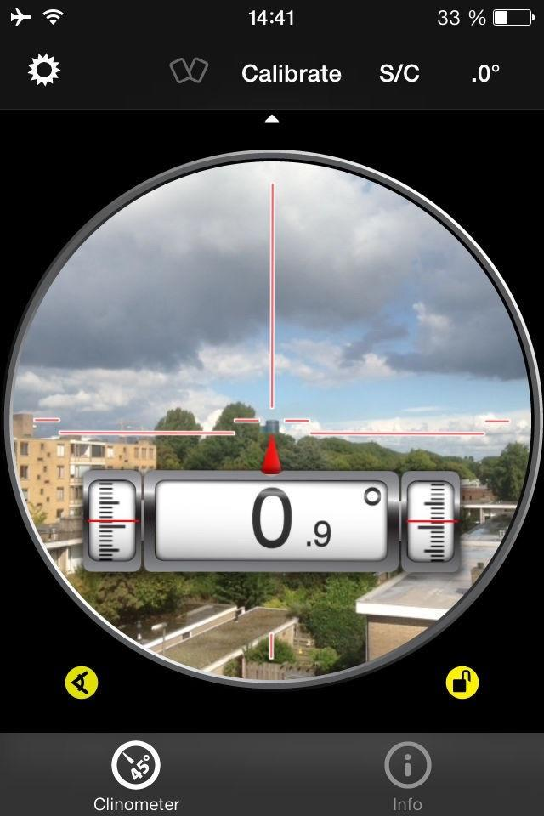
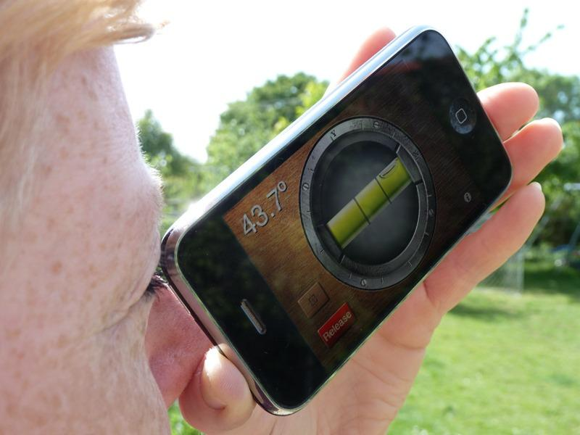
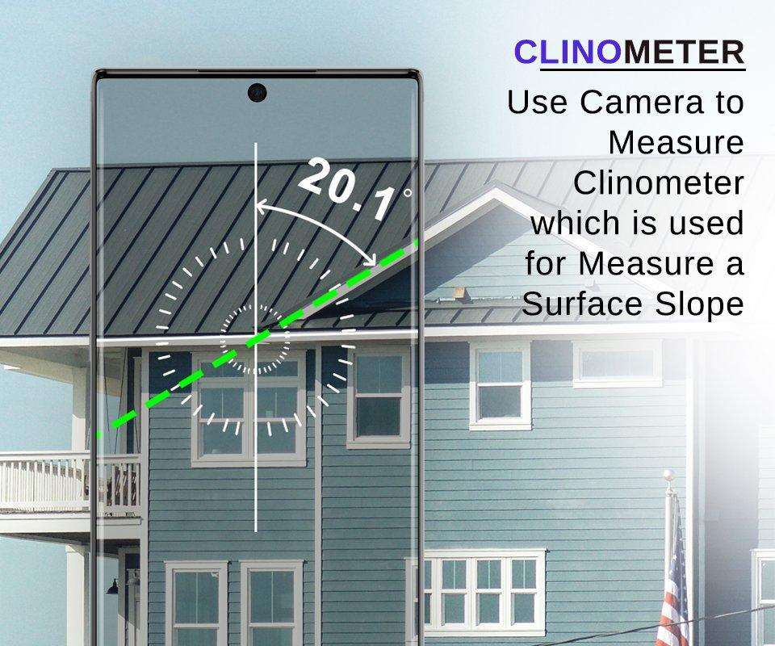
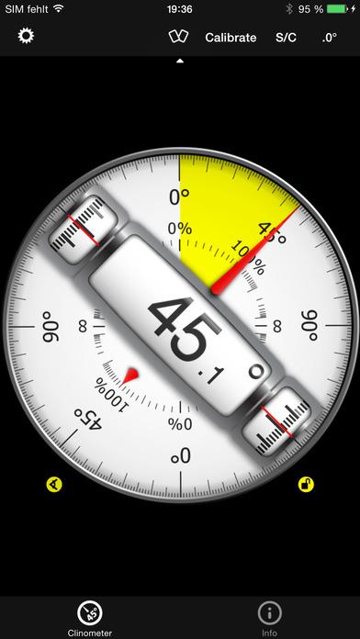
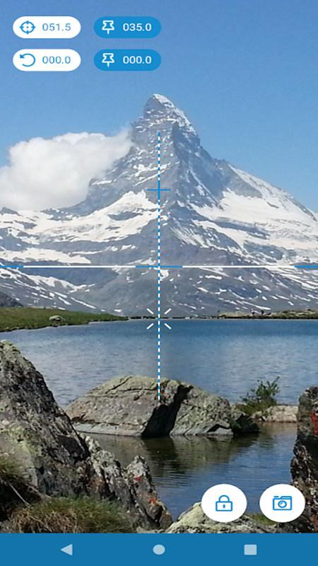
Description
Uses the phone's internal sensors to function as a clinometer.
Applications
- Education
- DIY projects
- General measurements

Measuring Units
# Source: AI Source: Provided by: [Data Path: Persons Table -> ID Column: 1, Name_En Column: Motasem Essam] -> From: [ChatGPT] on [7/17/2026]
A clinometer typically measures:
- Degrees (°)
- Percent slope (%)
- Rise over run (ratio) (some models)

Measuring Range
# Source: AI Source: Provided by: [Data Path: Persons Table -> ID Column: 1, Name_En Column: Motasem Essam] -> From: [ChatGPT] on [7/17/2026]
Typical measuring ranges:
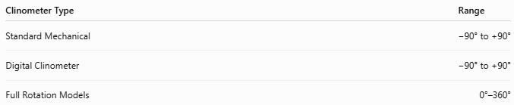
Clinometer Type | Range
Standard Mechanical | −90° to +90°
Digital Clinometer | −90° to +90°
Full Rotation Models | 0°–360°

Resolution
# Source: AI Source: Provided by: [Data Path: Persons Table -> ID Column: 1, Name_En Column: Motasem Essam] -> From: [ChatGPT] on [7/17/2026]
Typical resolutions:
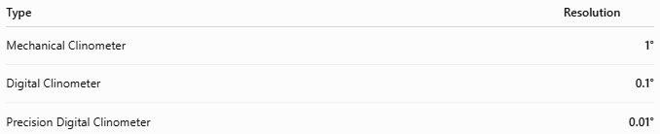
Type | Resolution
Mechanical Clinometer | 1°
Digital Clinometer | 0.1°
Precision Digital Clinometer | 0.01°

How to Use a Clinometer
# Source: AI Source: Provided by: [Data Path: Persons Table -> ID Column: 1, Name_En Column: Motasem Essam] -> From: [ChatGPT] on [7/17/2026]
- Hold the clinometer steadily.
- Sight the object using the sight line or viewing window.
- Allow the pointer or digital reading to stabilize.
- Read the displayed angle.
- Record the result.

Example
# Source: AI Source: Provided by: [Data Path: Persons Table -> ID Column: 1, Name_En Column: Motasem Essam] -> From: [ChatGPT] on [7/17/2026]
Suppose the clinometer reads:
35°
This means the object is inclined 35 degrees above the horizontal.

Measuring Height Using a Clinometer
# Source: AI Source: Provided by: [Data Path: Persons Table -> ID Column: 1, Name_En Column: Motasem Essam] -> From: [ChatGPT] on [7/17/2026]
If:
- Distance from observer to object = 20 m
- Angle of elevation = 35°
Then:
$$\text{Height}=\text{Distance}×tan⁡\left(θ\right) \\ \text{Height}=20×tan⁡\left({35}^{∘}\right) \\ \text{Height}≈14\text{ m}$$

Accuracy
# Source: AI Source: Provided by: [Data Path: Persons Table -> ID Column: 1, Name_En Column: Motasem Essam] -> From: [ChatGPT] on [7/17/2026]
Accuracy depends on:
- Instrument calibration
- Sensor quality
- User stability
- Proper sighting technique
High-quality digital clinometers typically provide much greater precision than mechanical models.

Sources of Error
# Source: AI Source: Provided by: [Data Path: Persons Table -> ID Column: 1, Name_En Column: Motasem Essam] -> From: [ChatGPT] on [7/17/2026]
Instrument Errors
- Sensor drift
- Worn mechanical components
- Calibration errors

User Errors
- Improper alignment
- Hand movement
- Incorrect reading

Environmental Errors
- Strong vibration
- Temperature changes
- Magnetic interference (for models incorporating a compass)

Applications
# Source: AI Source: Provided by: [Data Path: Persons Table -> ID Column: 1, Name_En Column: Motasem Essam] -> From: [ChatGPT] on [7/17/2026]
Clinometers are used in:
- Surveying
- Construction
- Civil engineering
- Architecture
- Forestry
- Geology
- Mining
- Aviation
- Road construction
- Sports (e.g., skiing and golf course design)

Advantages
# Source: AI Source: Provided by: [Data Path: Persons Table -> ID Column: 1, Name_En Column: Motasem Essam] -> From: [ChatGPT] on [7/17/2026]
A clinometer:
- Measures slope quickly.
- Is portable.
- Is easy to use.
- Can measure elevation and depression angles.
- Digital models provide high precision and fast readings.

Limitations
# Source: AI Source: Provided by: [Data Path: Persons Table -> ID Column: 1, Name_En Column: Motasem Essam] -> From: [ChatGPT] on [7/17/2026]
A clinometer:
- Requires proper alignment for accurate readings.
- Mechanical models are generally less precise than digital versions.
- Digital models require batteries or charging.
- Some calculations (such as determining height) require an additional distance measurement.

Comparison with Other Angle Measuring Instruments
# Source: AI Source: Provided by: [Data Path: Persons Table -> ID Column: 1, Name_En Column: Motasem Essam] -> From: [ChatGPT] on [7/17/2026]
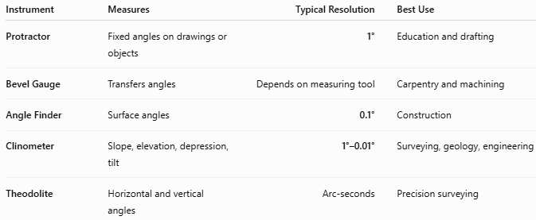
Instrument | Measures | Typical Resolution | Best Use
Protractor | Fixed angles on drawings or objects | 1° | Education and drafting
Bevel Gauge | Transfers angles | Depends on measuring tool | Carpentry and machining
Angle Finder | Surface angles | 0.1° | Construction
Clinometer | Slope, elevation, depression, tilt | 1°–0.01° | Surveying, geology, engineering
Theodolite | Horizontal and vertical angles | Arc-seconds | Precision surveying

Care and Maintenance
# Source: AI Source: Provided by: [Data Path: Persons Table -> ID Column: 1, Name_En Column: Motasem Essam] -> From: [ChatGPT] on [7/17/2026]
To maintain accuracy:
- Keep the viewing window clean.
- Store in a protective case.
- Avoid dropping the instrument.
- Replace batteries when required.
- Calibrate periodically.
- Protect electronic models from moisture unless rated for outdoor use.

Common Mistakes
# Source: AI Source: Provided by: [Data Path: Persons Table -> ID Column: 1, Name_En Column: Motasem Essam] -> From: [ChatGPT] on [7/17/2026]
- Holding the instrument at an incorrect angle.
- Reading the scale before it stabilizes.
- Confusing elevation and depression angles.
- Forgetting to calibrate digital models.
- Measuring from an uneven reference surface.

Key Points
# Source: AI Source: Provided by: [Data Path: Persons Table -> ID Column: 1, Name_En Column: Motasem Essam] -> From: [ChatGPT] on [7/17/2026]
- A Clinometer measures inclination, slope, elevation, depression, and tilt.
- Common types:
  - Mechanical Clinometer
  - Digital Clinometer
  - Geological Clinometer
  - Smartphone Clinometer
- Typical measuring range:
  - −90° to +90°
- Typical digital resolution:
  - 0.1° or 0.01°
- Widely used in surveying, geology, construction, engineering, forestry, mining, and architecture.

Conclusion
# Source: AI Source: Provided by: [Data Path: Persons Table -> ID Column: 1, Name_En Column: Motasem Essam] -> From: [ChatGPT] on [7/17/2026]
A Clinometer is a versatile angle-measuring instrument designed to determine the inclination, slope, elevation, or depression of objects relative to a reference plane. By using either a gravity-based mechanical mechanism or modern electronic tilt sensors, it provides quick and reliable angular measurements for a wide range of applications. From estimating tree heights and surveying land to aligning machinery and measuring roof pitches, the clinometer remains an essential tool in engineering, construction, geology, forestry, and many other technical fields.

